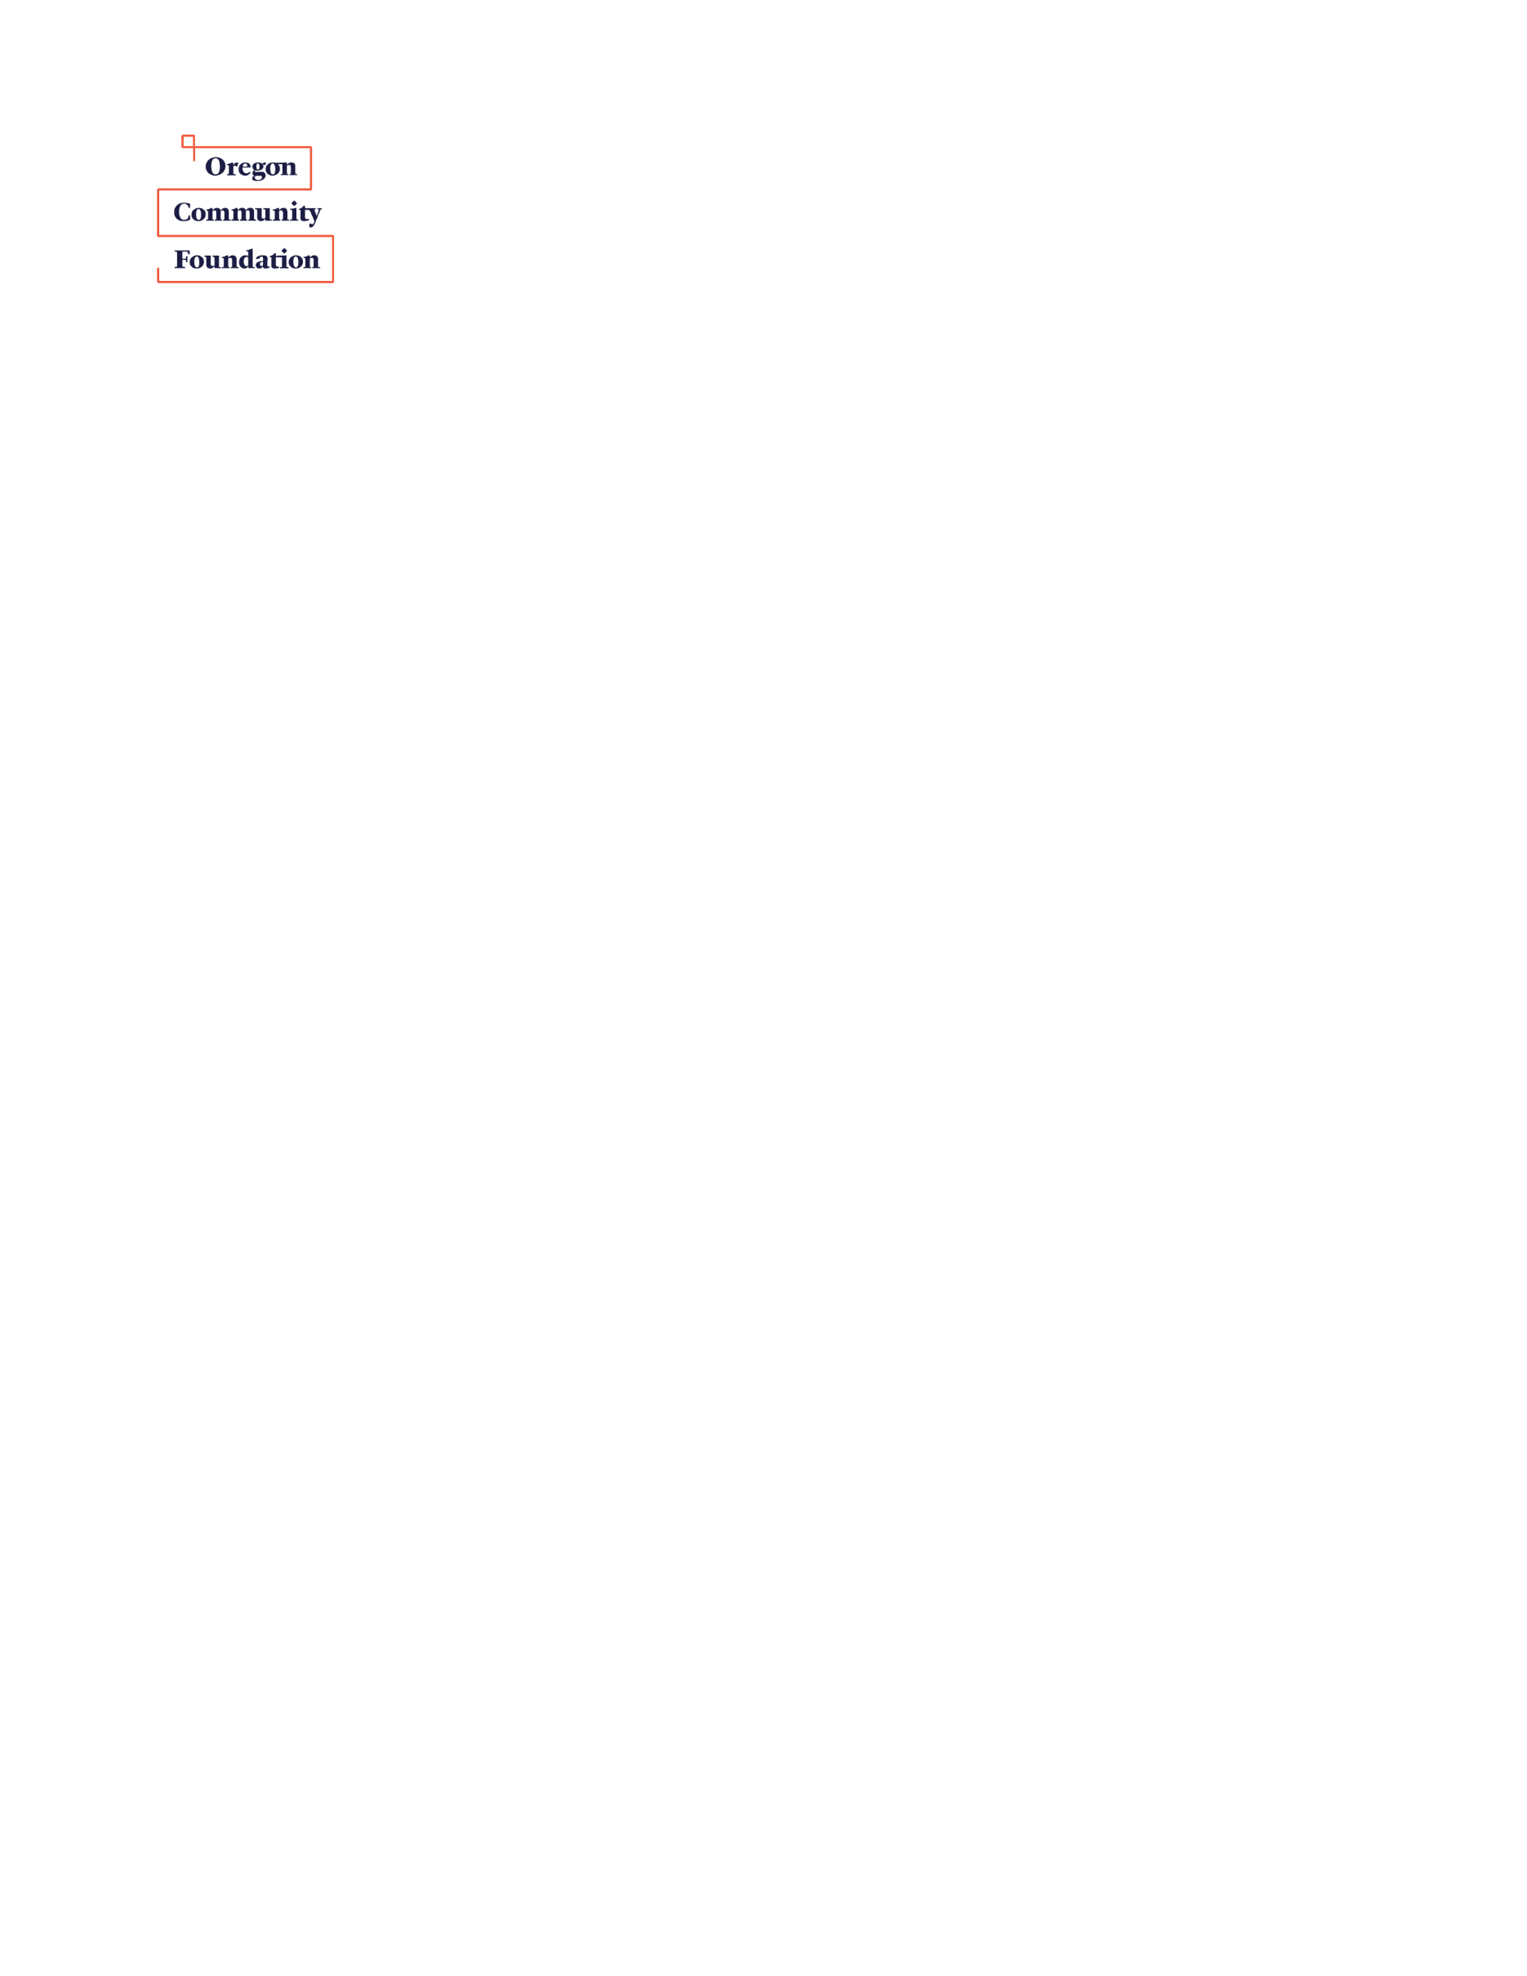**Grant Application Summary Form**

**Improving Arts Education in Schools**

.

|  |  |  |
| --- | --- | --- |
| **Date:** |  | Please fill in the requested information on this form and submit it with the required attachments. **Completed Applications must be received by March 8th, 2019, 5 p.m.** |

|  |  |  |  |  |  |  |  |  |  |  |  |  |  |  |  |  |  |  |  |  |  |  |  |  |  |  |
| --- | --- | --- | --- | --- | --- | --- | --- | --- | --- | --- | --- | --- | --- | --- | --- | --- | --- | --- | --- | --- | --- | --- | --- | --- | --- | --- |
| **Organization Name** | | | | | | |  | | | | | | | | | | | | | | | | | | | |
| Alternate name/acronym | | | | | | |  | | | | | | | | | | | | | | | | | | | |
| Fiscal sponsor if applicable | | | | | | |  | | | | | | | | | | | | | | | | | | | |
| Address |  | | | | | | | | | | | | | | | | | | | | | | | | | |
| City |  | | | | | | | | | State | |  | | | | | | | Zipcode | | |  | | | | |
| County |  | | | | | | | | | Website | |  | | | | | | | | | | | | | | |
| Phone # |  | | | | | | | | | Fax # | |  | | | | | | | | | | | | | | |
| **Executive Director or Board Chair** | | | | | | | | | | | | | | | | | Prefix (Mr., Ms., etc.) | | | | | | |  | | |
| First Name | |  | | | | | | | Last Name | | | |  | | | | | | | | | | | | | |
| Title | |  | | | | | | | | | | | E-Mail | | | | |  | | | | | | | | |
| **Mission & Primary Activities** | | | | |  | | | | | | | | | | | | | | | | | | | | | |
| Counties where services are provided | | | | | | | |  | | | | | | | | | | | | | | | | | | |
| Employer ID number (EIN) | | | | |  | | | | | | | | | | | Year org. established | | | | | | | | |  | |
| Number of paid employees | | | | |  | | | | | FTE |  | | | | | Number of volunteers | | | | | | | | |  | |
| Number of board members | | | |  | | Number of board members who contribute to annual budget | | | | | | | |  | | | | | | | Number of board meetings per year | | | | |  |
| **Organization Financial Information** | | | Organization budget for **current** **year** | | | | | | | | | | | |  | | | | | | | |  | | | |
| Organization expenditure total for **last** **year** | | | | | | | | | | | |  | | | | | | | | Which calendar or fiscal year do these (last year) figures represent? | | | |
| Organization revenue total for **last** **year** | | | | | | | | | | | |  | | | | | | | |
| Revenue breakdown  for last  year | | | Memberships | | | | | | | | | | | |  | | | | | | | |
| Individual contributions | | | | | | | | | | | |  | | | | | | | |
| Earned income (ticket sales, fees for service, etc.) | | | | | | | | | | | |  | | | | | | | |
| Fundraising benefits | | | | | | | | | | | |  | | | | | | | |
| Corporate/business contributions | | | | | | | | | | | |  | | | | | | | |
| Government support | | | | | | | | | | | |  | | | | | | | |
| Foundation support | | | | | | | | | | | |  | | | | | | | |
| Endowment earnings | | | | | | | | | | | |  | | | | | | | |
| Other (identify sources): | | | | | | | | | | | |  | | | | | | | |
| Organization’s unrestricted cash reserves at beginning of **current year** | | | | | | | | | | | | | | | | | | | |  | | | | | | |
| From last year’s revenue sources, please list the five single largest contributors and amounts provided.  (Contributors include specific individuals, agencies, businesses, foundations, or other groups. Individuals may be listed as Anonymous #1, #2, etc., if necessary.) | | | | | | | | | | | | | | | | | | | | | | | | | | |
|  | | | | | | | | | | | | | | | | | | | | | | | | | | |
| Please list grant applications to OCF and amounts awarded during the past three years. | | | | | | | | | | | | | | | | | | | | | | | | | | |
|  | | | | | | | | | | | | | | | | | | | | | | | | | | |

|  |  |  |  |  |  |  |  |  |  |  |  |  |  |  |  |  |  |  |
| --- | --- | --- | --- | --- | --- | --- | --- | --- | --- | --- | --- | --- | --- | --- | --- | --- | --- | --- |
| **Lead Agency Project Contact Person** | | | | | | | | | | | | Prefix (Mr., Ms., etc.) | | | |  | | |
| Name |  | | | | | | | | Title | | |  | | | | | | |
| Phone |  | | | | | | | | E-mail | | |  | | | | | | |
| **Project Description** (one sentence) | | |  | | | | | | | | | | | | | | | |
| **Key Program Components** (Max 150 words. A snapshot of your project, including population to be served and measurable outcomes) | | |  | | | | | | | | | | | | | | | |
| In what counties are services provided? | | | | | | | | | | |  | | | | | | | |
| **Project Budget** | | Total project budget | | | |  | | | | | | | Total 2-year request | | | |  | |
| Please note budget figures for each year | | | | | | | | | | | | | | | | | | |
| Budget year 1 | |  | | | | | | Request of OCF for year 1 | | | | | |  | | | | |
| Budget year 2 | |  | | | | | | Request of OCF for year 2 | | | | | |  | | | | |
| Please list other funding sources for your programming (and amounts for each) and indicate if the funding has been secured with “Yes” or “No”. You may include the value of in-kind support. | | | | | | | | | | | | | | | | | | |
|  | | | | Secured? |  | |  | | |  | | | | | Secured? | | |  |
|  | | | | Secured? |  | |  | | |  | | | | | Secured? | | |  |
|  | | | | Secured? |  | |  | | |  | | | | | Secured? | | |  |
|  | | | | Secured? |  | |  | | |  | | | | | Secured? | | |  |

With my signature I certify the following: (1) The above information is correct; (2) I am authorized by the governing board of this organization to submit this grant application to The Oregon Community Foundation; (3) this organization is in good standing with the IRS, retains its 501(c)(3) tax‑exempt status, and is further classified as a public charity and *not* a private foundation; (4) this organization does not discriminate on the basis of race, color, religion, gender, gender identity or expression, sexual orientation, physical circumstances, age, status as a veteran, or national origin. I also agree to comply with the stated expectations below and understand that compliance with the expectations will be an eligibility condition for grant renewal in subsequent year.

|  |  |  |
| --- | --- | --- |
|  |  |  |
| Name (printed) of head of organization |  | Title |
|  |  |  |
| Signature of head of organization (director or board chair) |  | Date |

**Required: Please include as attachments with this application summary form**

Application summary (this document, two pages)

Detailed application narrative (no more than four pages, 11-point font)

Detailed 2-year program budget, including revenues and expenditures (one page)

Brief budget narrative

2-year project timeline

Letter(s) of commitment from confirmed project partner(s) detailing their role in the project

Lead organization budget for current year, including revenues and expenditures to date (one page)

Lead organization budget for past year, including revenues and expenditures (one page)

Financial statements

**Optional:**

Letters of support

List of board of directors with affiliations & phone numbers, plus the skills and experience each contributes

Letter from the IRS granting 501(c)(3) tax-exempt status (if applicable)

***Do NOT include*** *any media*

Only e-mailed copies of applications will be accepted. No mailed or dropped off copies.

Due by March 8, 2019, 5pm to: [artsed@oregoncf.org](mailto:artsed@oregoncf.org)

*(CDs, DVDs, books, etc.).*

Bottom2bw.jpg**Application Narrative** *Please keep form to* ***no more than four pages, using 11-point font.***

**Describe your organization.** *What is your mission and track record? Highlight two or three key facts and accomplishments that best define you. What community need does your organization address?*

**Describe the target population to be served through your project.** *Include specific geographic and demographic information and about the students and families (grade levels, ethnicity, income, etc.).*

**Describe the current arts learning environment and activities at the school(s) involved in project.** *Include information regarding arts learning opportunities and resources over the past three years (including FTEs dedicated to arts, residencies, in-school vs. out-of-school time programming, etc.).*

**Describe any partner organization(s) involved in project and their role.** *Include mission and track record with providing arts education programs. Describe if these partnerships are new or existing. How will project partners work together to ensure success?**How will the project be coordinated? What is the communication plan for partners?*

**What aspects of your existing arts education programming do you wish to improve?** *What is the program you wish to strengthen over the grant period? Why do you wish to work on this program? What are the greatest opportunities for improvement? How were these opportunities determined?*

**How will you make these improvements?** *What are some specific proposed activities, methods and strategies related to the opportunities for improvement? What other activities or collaborations might be supported (sequential arts instruction, exposure, arts integration, etc.)? Be sure that this plan correlates with your attached timeline. If new modes or methods of teaching are planned, what best practices or other models are being consulted or emulated?*

**Which Studio-to-School principles are most connected to this work?** *Indicate the most relevant principles (two maximum) and describe how your proposal is connected to these principles.*

**What type of technical assistance or expertise do you need to accomplish your goals?** *What do partners hope to learn through this project?**How will professional development be incorporated?*

**How will you know that you have succeeded?** *Describe your objectives and anticipated outcomes for the project. What do you hope to learn or expect to accomplish? What are your strengths and challenges related to evaluating your program and using data for program improvement?*

**Conclusion** *How does this project help develop, implement or sustain community-supported arts education programming? How will this project promote equitable access to high-quality arts education in Oregon? Why does it matter to your community?*